**Find Date Difference**

1. **Add Task Description:**

Creating a application which is find Year, Month, Day Difference Between Two Date(From Date(Selected by User), To Date(User Current Date).

Select date using DatePIckerDialog in ‘dd-mm-yyyy’ format and match it in current date. After give the difference between this.

1. **Attach Screenshot of Output.**

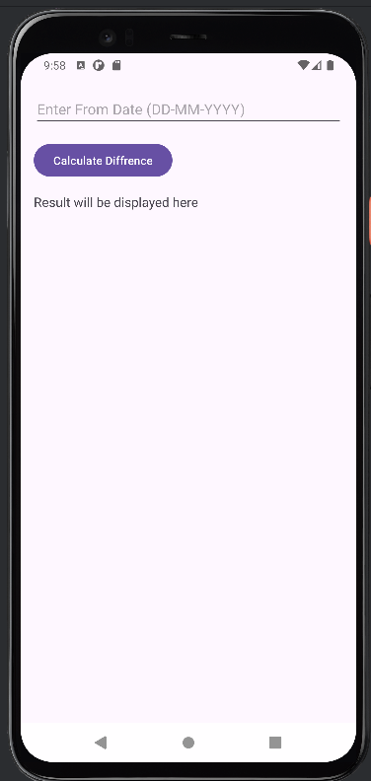 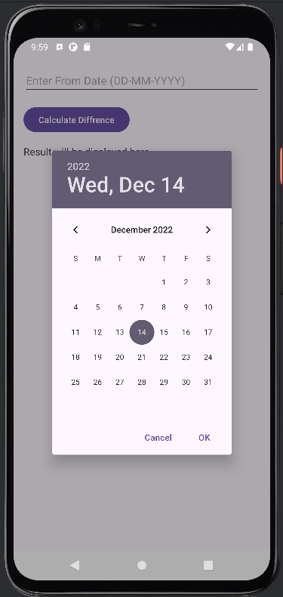 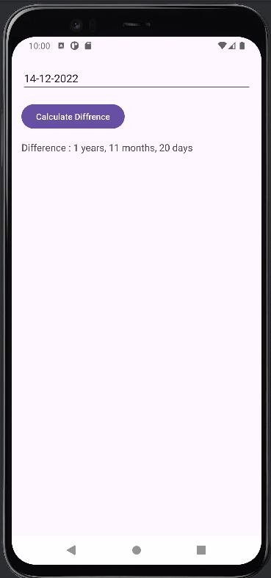

1. **Describe Widget/Algorithm Used In Task**

**DatePickerDialog:** Display date picker and selecte the date by user.

**Listview :** Listview display a data in vertical list of scroll-able views

**Search view :** Search view provides user interface to search data/item/query and filter the data.

**Data Model :** To represent each news item.